PDA in Software Programming

# Evidence for Implementation and Testing Unit

Simon Atkins - Cohort e20

## I.T 1- Demonstrate one example of encapsulation that you have written in a program

In this programme, private variables such as Airport Name and ArrayList of Planes are encapsulated within the Airport class and can only be accessed with getters such as .getName().

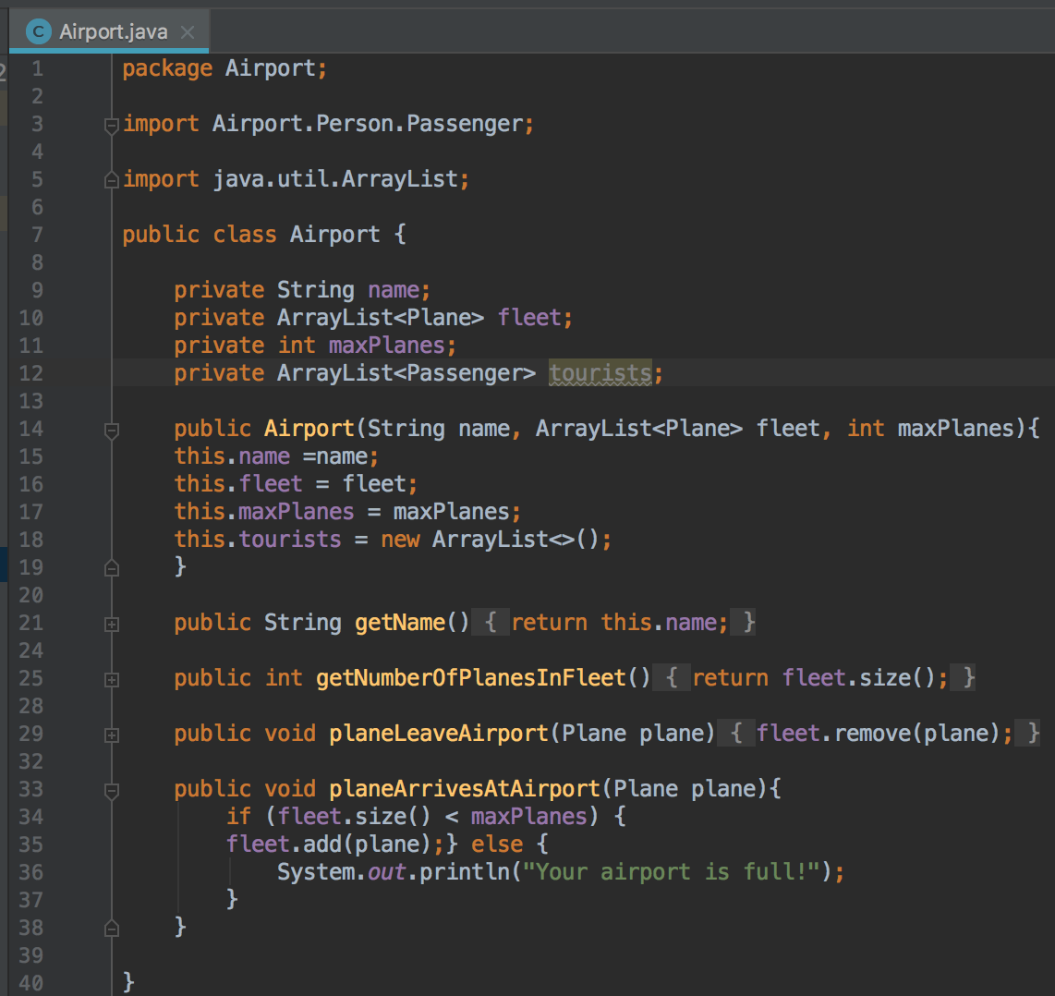

## I.T 2 - Example the use of inheritance in a program.

In this Warcraft program, the Barbarian class inherits from both the Fighter and the Player classes. The Barbarian is able to access the ‘weapon’ method because of the Fighter class directly above, and the ‘name’ method because of the Player abstract class at the top.

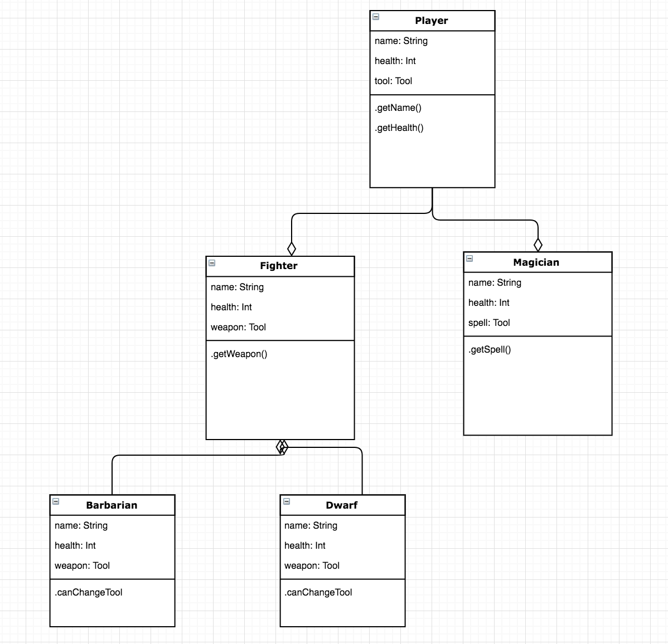

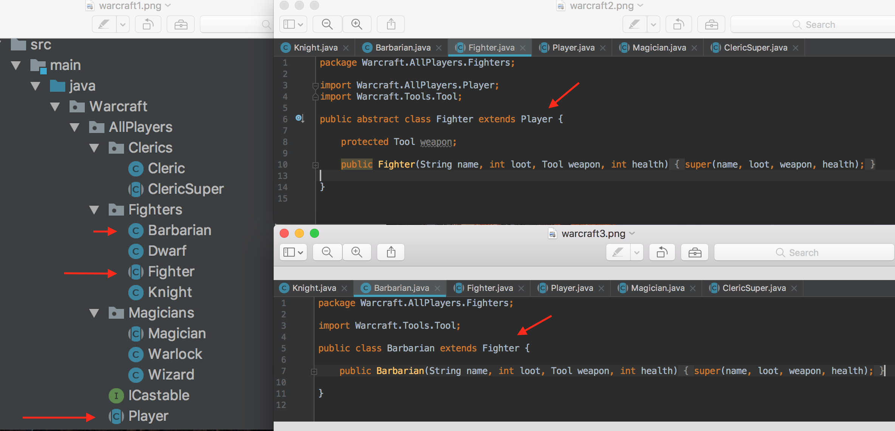

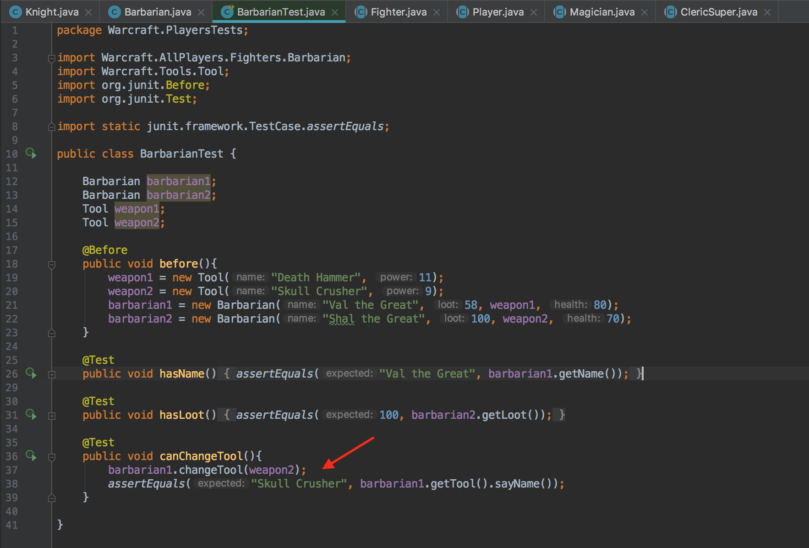

## I.T 3 - Example of searching

(if you do not have a search and sort algorithm, write one up, take a screenshot. Remember to include the results as well.)

Evidence for unit: A Ruby function & result

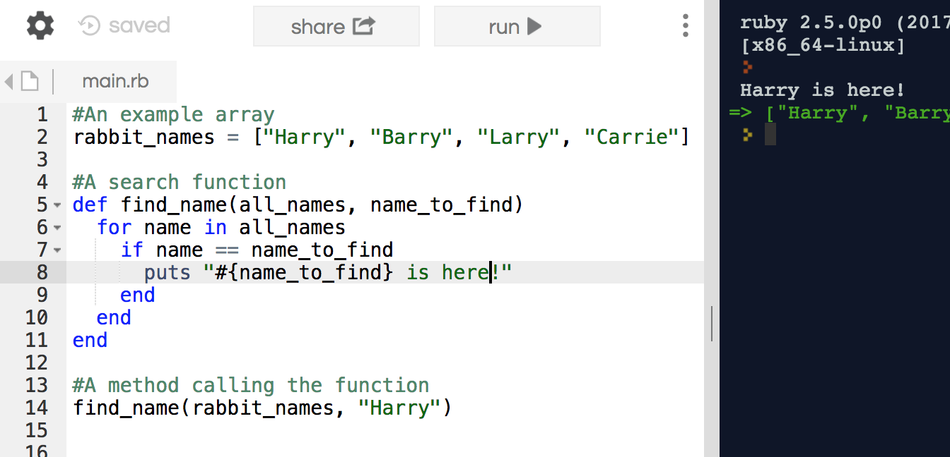

Evidence for unit: A ruby and SQL search function

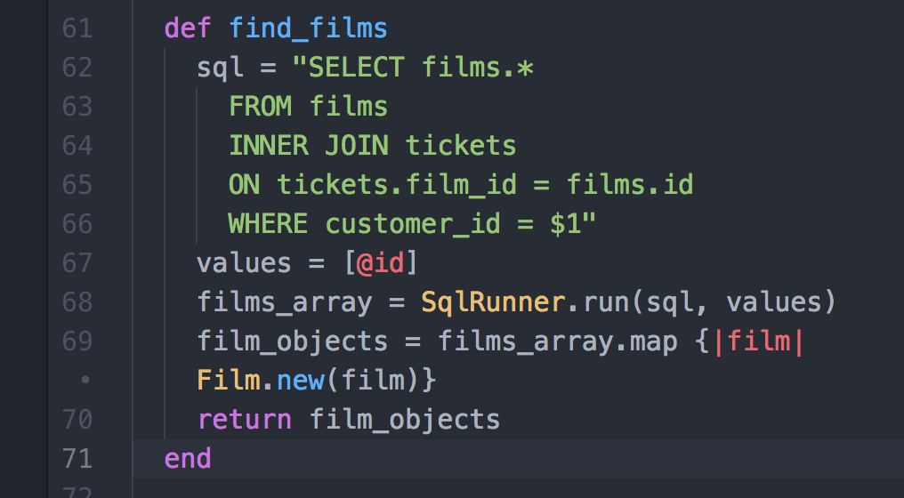

Evidence for unit: Terminal showing result of calling the Ruby/SQL function above

## I.T 4 – Example of sorting

Evidence for unit

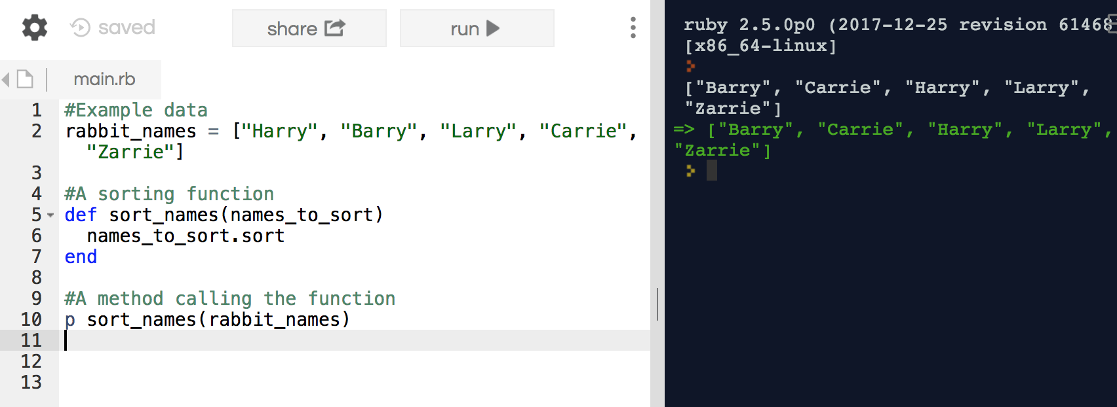

## I.T 5 - Example of an array, a function that uses an array and the result

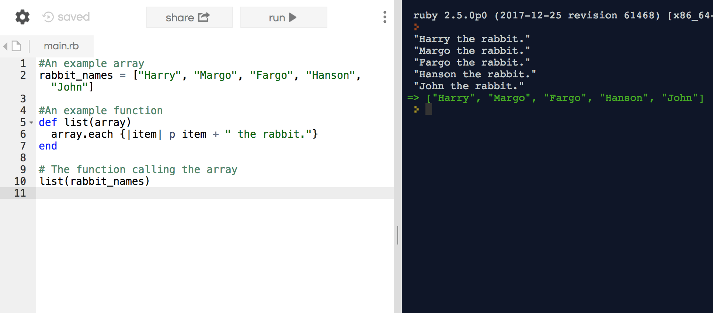

## I.T 6 - Example of a hash, a function that uses a hash and the result

## Evidence for unit

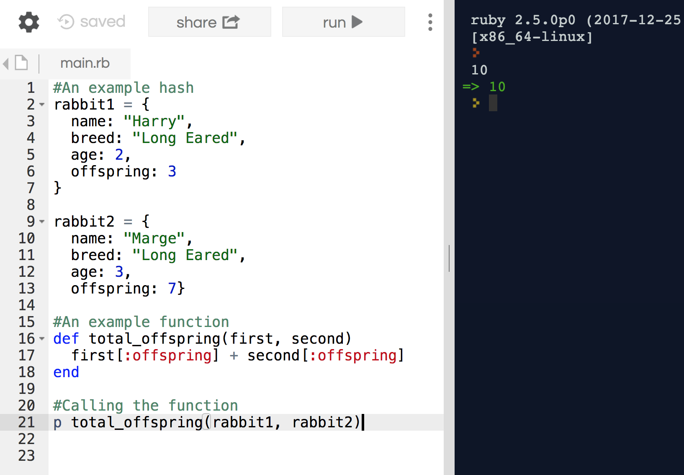

## I.T 7 - Example of polymorphism in a program

In this Airport programme, Consumables classes such as Nuts and Sandwiches implement the IBuyable interface, allowing them to be collected within an ArrayList of IBuyables. Here the ArrayList is a ‘backpack’ and the Testing (second screenshot) shows that the interface is working.

## 

## 

## 

## I.T - Coding Exercise 1: Static & Dynamic Testing

Screen shot of static testing

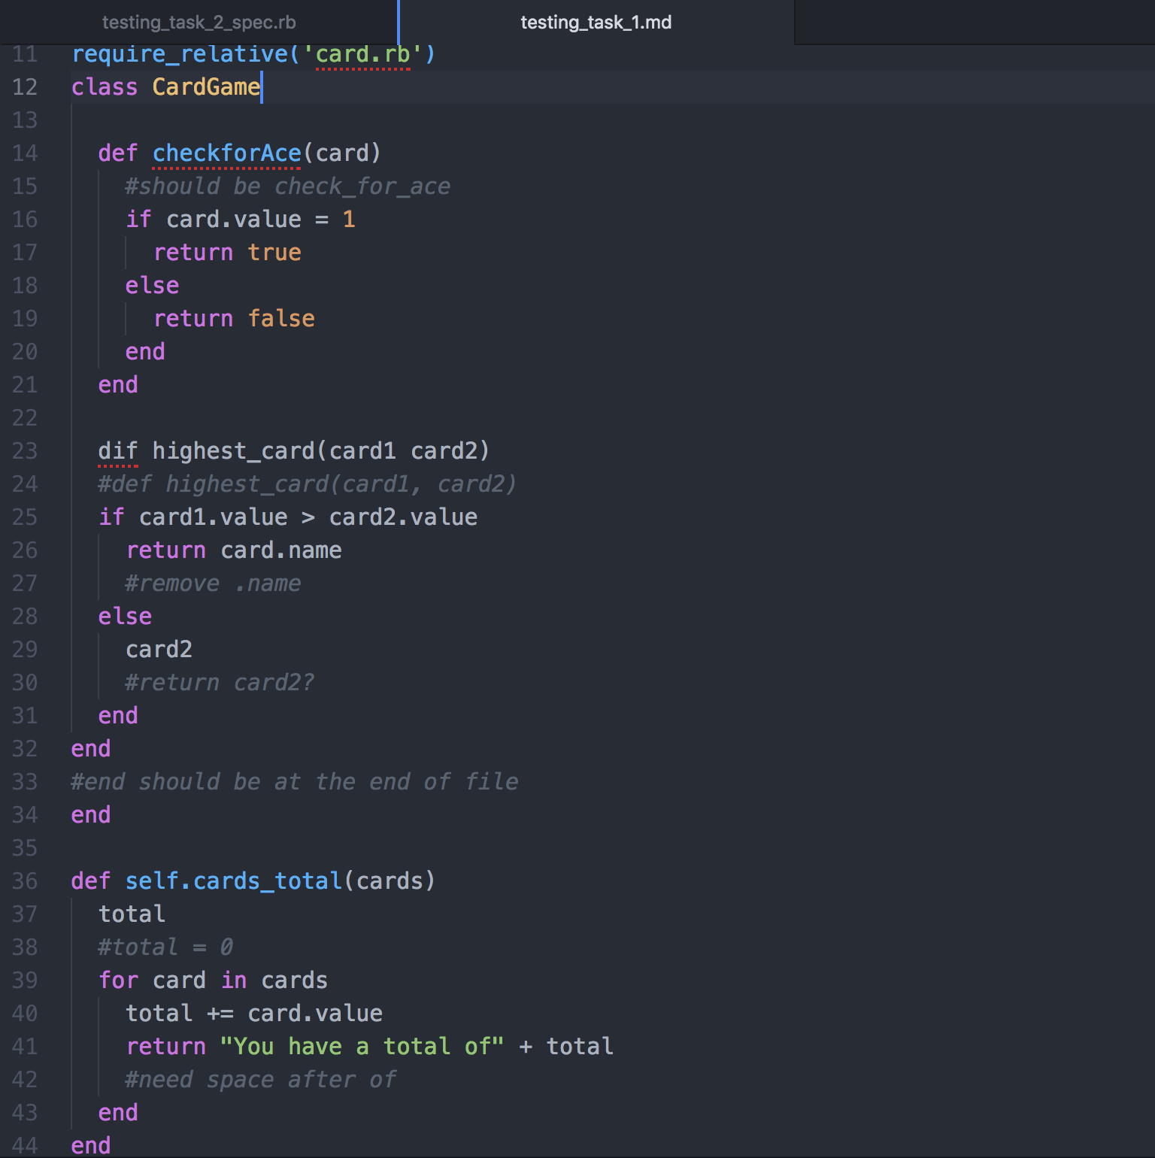

Screen shot of tests failing

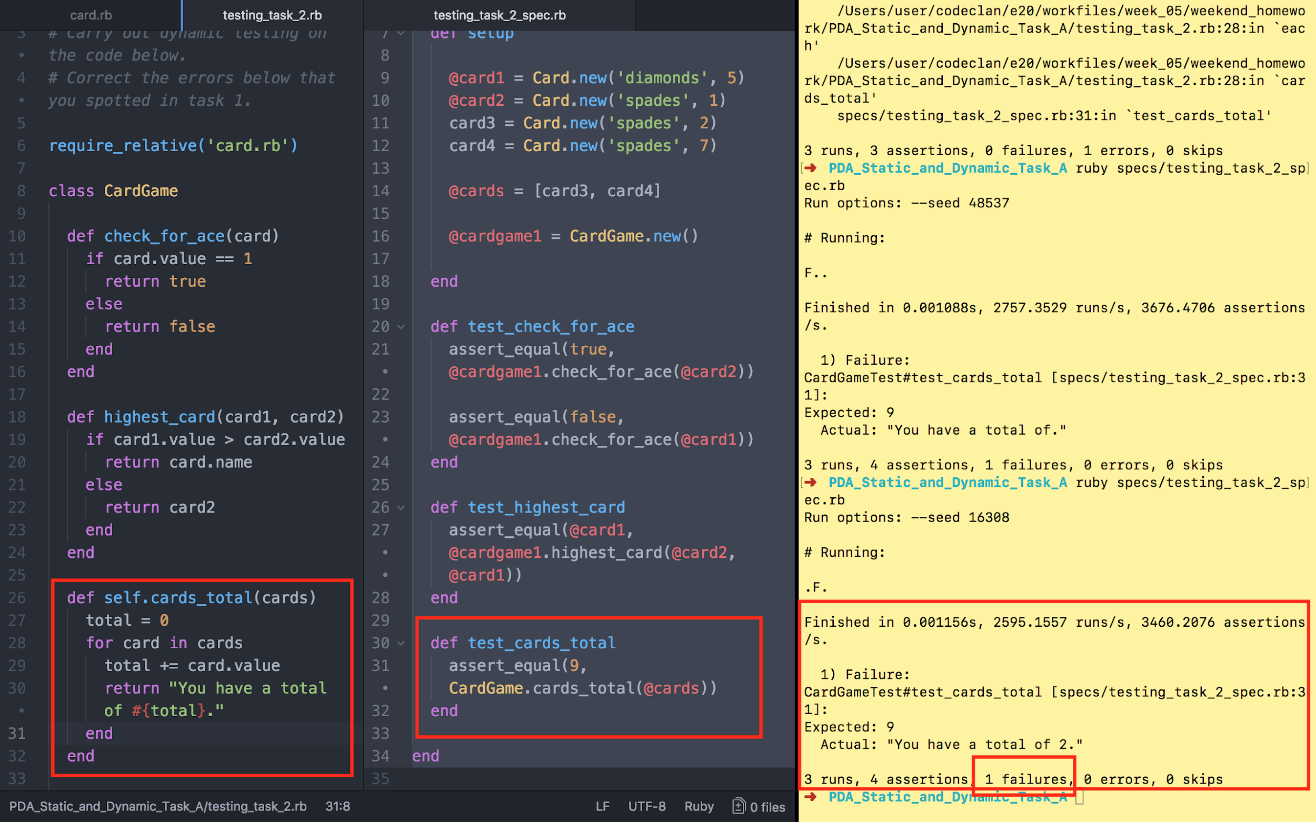

Screen shot of tests passing

